1.2 Homework continued

3. Please complete the following magic square problems. (Remember to write the operations above and below the magic square.)
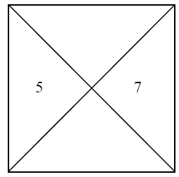

-9
18
31
30

27

3
5
6

